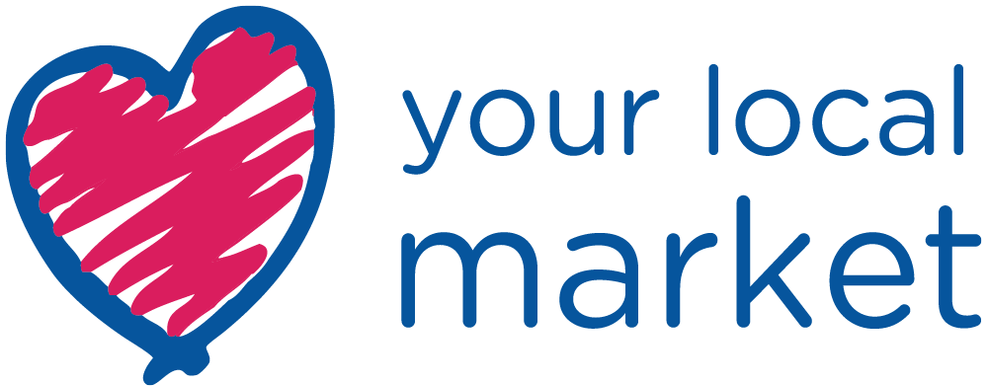
[Insert Date that you are sending out the release here or use an embargo]

PRESS RELEASE

Headline here: Make it clear and eye-catching
no more than two lines

Sub-header here: Explain the headline a little, the relevant
dates and a web link if there is one

OR USE
Love Your Local Market 2022 #LYLM2023
Friday 12th May to Saturday 27th May 2023
nabma.com

- The first paragraph is all-important – journalists may not read on any further. Remember the five W’s – what is happening? Where? When? Who is taking part? Why should the journalist be interested? If any of these points have not been addressed in the headline and sub-header, make sure they are covered here. Stress the point that the event is free. Always attached at least two good quality images.

- Go into a little more detail in the second paragraph. If you have a quote, include it here. Add some colour to the details in the first paragraph; try and pull out specifics, rather than generics.

- Make the third paragraph more factual – give details about the location; other things to see and do. Try and give a little local context to the location? Are there any special facilities for children/families?

- Conclude with clear, concise organisational details; is the activity open on every day of Love Your Local Market campaign? Do you need to book in advance? Is there any restriction on numbers?

ENDS

For media enquiries and images contact: Put in one name, a telephone number, and an email address. Check and DOUBLE CHECK that these details are correct, it’s amazing how many releases go out with incorrect contact details.

