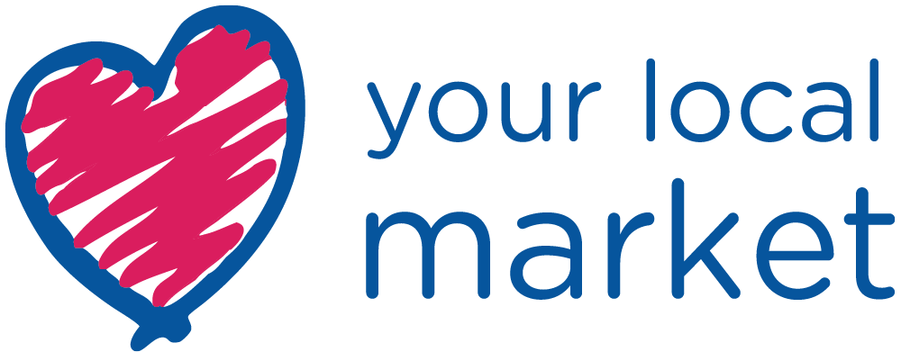
[Insert Date that you are sending out the release here or use an embargo]

PRESS RELEASE

Headline here: Make it clear and eye-catching
no more than two lines

Sub-header here: Explain the headline a little, the relevant
dates and a web link if there is one

OR USE
Love Your Local Market 2022 #LYLM2022
Friday 13th May to Sunday 5th June 2022
nabma.com

- The first paragraph is all-important – journalists may not read on any further. Remember the five W’s – what is happening? Where? When? Who is taking part? Why should the journalist be interested? If any of these points have not been addressed in the headline and sub-header, make sure they are covered here. Stress the point that the event is free. Always attached at least two good quality images.

- Go into a little more detail in the second paragraph. If you have a quote, include it here. Add some colour to the details in the first paragraph; try and pull out specifics, rather than generics.

- Make the third paragraph more factual – give details about the location; other things to see and do. Try and give a little local context to the location? Are there any special facilities for children/families?

- Conclude with clear, concise organisational details; is the activity open on every day of Love Your Local Market campaign? Do you need to book in advance? Is there any restriction on numbers?

ENDS

For media enquiries and images contact: Put in one name, a telephone number, and an email address. Check and DOUBLE CHECK that these details are correct, it’s amazing how many releases go out with incorrect contact details.

Optional Quotes & Background Information:

We encourage organisers to use these quotes from NABMA. These must be used exactly as they are appear here and not altered in any way.

NABMA President, Councillor Mick Barker said: ‘This year’s theme, “Celebrate with your local market” reflects the importance of markets as the beating heart of communities across our villages, towns, and cities, as we all join in the Queen’s Jubilee celebrations. We are looking forward to hundreds of markets taking part again and thousands of customers enjoying the special events and activities.’

NABMA Chief Executive, David Preston said: ‘In the eleven years we have been celebrating Love Your Local Market, over 11,000 people have tried market trading for the first time and around 1,100 new businesses have been created. Markets are the perfect launching pad for business ideas and innovation. Contact your local market today.’

Optional Footnotes
Notes to Editors:

OPTIONAL FOOTNOTES: This is factual background information for journalists about Love Your Local Market to include in the body of your press release or as footnotes.

About NABMA:

- NABMA (the National Association of British Market Authorities) works to raise the profile of markets at national and local level, and the professionalism of market operators. We provide a wide range of services to our members training and advice on legal and technical issues impacting on markets. NABMA delivers the Great British Market Awards and has also developed and delivered the “Love Your Local Market” (LYLM) campaign which are the UK’s most successful celebration of markets.
About Love Your Local Market

- Now in its 11th year, the campaign has grown to become a global campaign with over 24 countries taking part. This year’s Love Your Local Market theme is ‘Celebrate with your Local Market’. Between Friday 13th May to Sunday 5th June 2022, events will showcase innovation, celebrating heritage, culture, produce, crafts and food. There will also be opportunities for new traders and enterprise initiatives encouraging young enterprise.

